**Moq HandsOn**

***Exercise:Moq Unit Test for Email Sending Logic***

**1)Code**

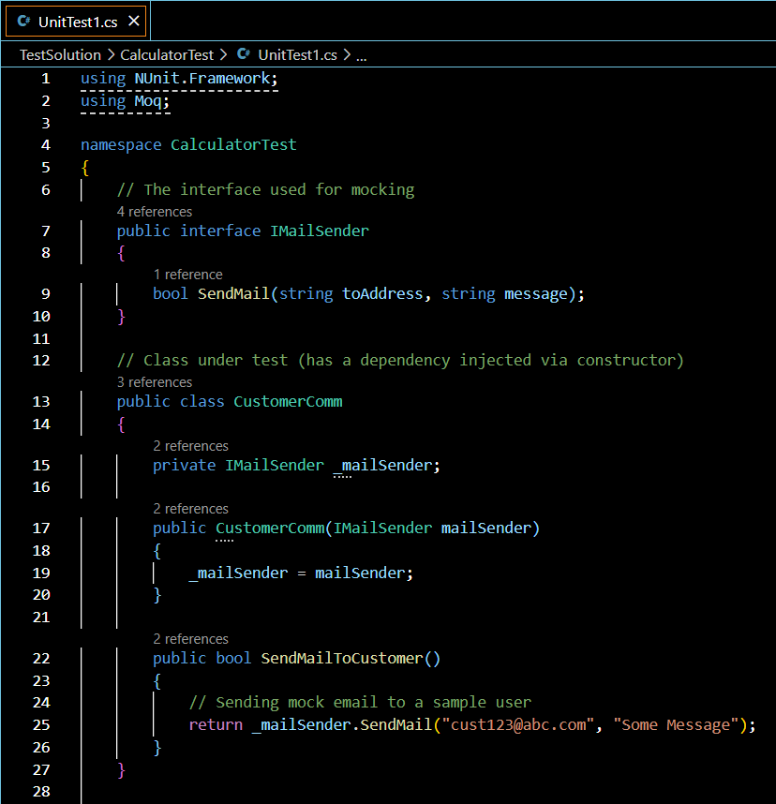

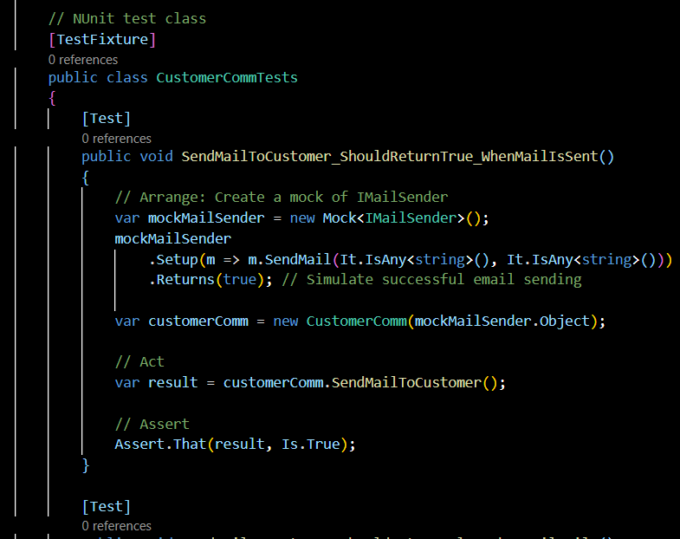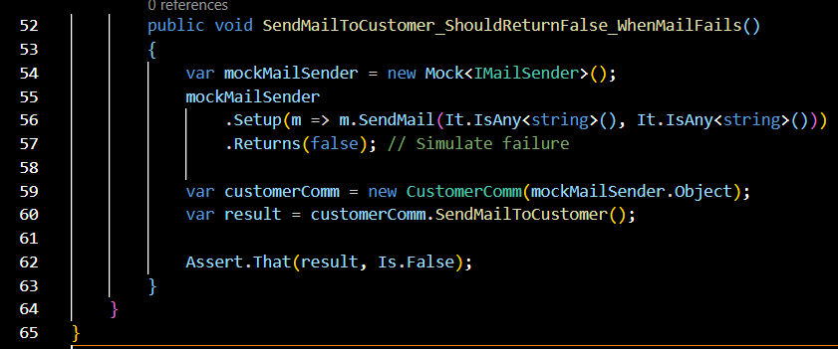

**2)Output**

